Insert School Name

Breaks are Better

Implementation Manual

2021-2022
Implementation Plan designed by the Tier II School Team Members:
INSERT TEAM MEMBER NAMES HERE

Note: Consider adding the contents of this manual to your Tier II Implementation Manual

Table of Contents
Breaks are Better (BrB) 3
Program Logistics 3
Tier II & BrB Calendar 4
Daily Progress Report 5
Copy of our Daily Progress Report (DPR) 6
Reinforcement System 7
Identifying Students 8
Identifying Students Cut-Off Score Grid 9
Data Management 10
Evaluate Intervention Outcomes 11
Plans for Self-Management, Fading, and Graduation 12
Copy of our Self-Management, Fading, and Graduation Flowchart 13
Tier II Intervention Grid 14
Training Stakeholders 15
BrB Implementation Checklist 18
Appendix 19

Breaks are Better (BrB)

Program Logistics
Our Tier II Team discussed the program logistics for implementing BrB. The details are listed in the chart below.

Program Logistics
What will we name the intervention in our school?
What will we call the Daily Progress Report?
Who will facilitate the intervention by providing daily check-in and check-out as BrB Mentors?
Can each of these in individuals have flexible schedules at the beginning and end of the day?
Are these adults positive and well-liked by students?
List BrB Mentors here:

Who will check students in and out if a BrB Mentor is absent?
Name at least one substitute for each identified BrB Mentor.

Where will daily check-in and check-out occur?
What is our plan for students who ride the bus, arrive late to school, or leave school early?
What will be the maximum number of students each BrB Mentor may serve at one time?

Tier II & BrB Calendar
Our Tier II Team discussed when our team will implement the Tier II System and BrB. In an effort to organize our implementation plan, we listed important components for BrB as well as any other Tier II intervention we are implementing. The details are listed in the chart below.

Tier II & BrB Calendar Components | Who | Date(s)
Meet to Complete Unfinished Training Workbook Activities
Transfer Workbook Activities into Tier II Implementation Manual
Tier II School Team Meetings  -Review Teacher Nominations  -Review entrance criteria to identify students  -Use Progress Monitoring Flowchart to discuss adaptations  -Use Progress Monitoring Flowchart to discuss fading  -Review exit criteria to discuss graduation |  | Bi-weekly to Monthly
Initial Session to Teach Components of BrB to Staff
Booster Sessions to Teach Components of BrB to Staff
Identify Initial Pilot Students for BrB
Explain BrB Process to Stakeholders  -Discuss with Students and Families  -Train BrB Mentors  -Remind Teachers of Participation | BrB Coordinator
Begin Piloting BrB
Review Student Data  -Use Progress Monitoring Tool (spreadsheet)  -Prioritize Students to Discuss with Team | BrB Coordinator
Evaluate Intervention Data  -DPR Reviews  -BrB Fidelity Checklists | BrB Coordinator
Begin Full BrB Implementation
Other Intervention Information:

Daily Progress Report
Our Tier II Team discussed considerations for creating the DPR. The details are listed in the chart below.

Daily Progress Report (DPR)
What are the school-wide behavioral expectations listed on the DPR?
What are the associated academic behaviors listed on the DPR?
How many rating periods will be included on the DPR?
What range of scores will be listed for rating behavioral performance (e.g., 1-3, 0-2)?
What criteria will define how points are earned (e.g., never, sometimes, often)?
What adaptations need to be made so that the DPR is age appropriate for all students you serve?
Will the DPR include pictures?
Will the DPR include start and end times for class periods?

How will the DPR data be provided to families?
Will the DPR be sent home or will there be a separate home communication sheet?
How often will the DPR data be shared with families?

How will parents/guardians respond to indicate they have seen and discussed DPR data with their child?

Copy of our Daily Progress Report (DPR)
Name |  |  |  | Date
 | Safe | Respectful | Prepared | Breaks taken the right way (if needed) OR not taken | 2-minute Breaks Left
 | Keep your hands to yourself | Raise your hand if you have something to say | Have your homework completed before class
Period 1 | 0 1 2 | 0 1 2 | 0 1 2 | 0 1 | B B B
Period 2 | 0 1 2 | 0 1 2 | 0 1 2 | 0 1 | B B B
Period 3 | 0 1 2 | 0 1 2 | 0 1 2 | 0 1 | B B B
Period 4 | 0 1 2 | 0 1 2 | 0 1 2 | 0 1 | B B B
Period 5 | 0 1 2 | 0 1 2 | 0 1 2 | 0 1 | B B B
Period 6 | 0 1 2 | 0 1 2 | 0 1 2 | 0 1 | B B B
Period 7 | 0 1 2 | 0 1 2 | 0 1 2 | 0 1 | B B B
Check-In Points Attends check-in 0 1
Was prepared 0 1
Check-Out Points Attended check-out 0 1
Teacher completed ratings 0 1
Today’s Goal_____ Today’s Total_____ Goal Met? Yes No
Parent Signature __________________________
All work due is complete _____
All work due is not complete _____
Our Tier II Team created the DPR that students will use during the BrB intervention. Each morning the student’s BrB Mentor will give them a new copy of the DPR, and teachers will use it to rate their behavior and provide structured positive and corrective feedback throughout the day.
INSERT YOUR DPR

Reinforcement System
Our Tier II Team discussed how to incorporative reinforcement as part of the BrB intervention. The details are listed in the chart below.
Reinforcement System
What reinforcers are available for student participation when checking in?
What reinforcers will students receive for checking out and meeting their daily point goal?
How will you ensure students do not become bored with the reinforcers?
Will students complete a preference assessment?
Will students have access to a reinforcement menu?

What if students are absent on a day they are supposed to earn reinforcement?
How will we offer a variety of reinforcers?
Will students earn daily, short-term, and/or long-term reinforcers?

Do we have any budget for our acknowledgment system?
How can our reinforcers be low-cost or no-cost?
How can we secure additional funding?

Identifying Students
Our Tier II Team discussed how students will be identified for BrB. The details are listed in the chart below.

Identifying Students
What are the “data flags” or entrance criteria for identifying students for referral to the BrB intervention?
How will the Tier II team make decisions about enrolling students into the BrB intervention?
What is the entrance criteria?

Who will develop the Teacher Nomination Form? Who gets it once it is completed?
When will this be completed?
When will this be shared?

If you use a universal behavior screener, what is the process for identifying students who transfer in after the screening period?
What is the process for determining whether students will begin the next school year in BrB?

Identifying Students Cut-Off Score Grid
This chart is a document the team used to organize school data as a way to identify students for Tier II. Update this chart to match the Cut-Off Score Grid in your Tier II Implementation Manual.
CUT-OFF SCORE GRID
Measure | Low Risk | Moderate Risk | High Risk | Date(s) to Review
ODR |  |  |  | Monthly
SRSS-IE12  Externalizing |  |  |  | Fall, Winter, Spring
SRSS-IE12  Internalizing |  |  |  | Fall, Winter, Spring
Unexcused  Absences |  |  |  | Monthly
Tardy |  |  |  | Monthly
ISS |  |  |  | Monthly
OSS |  |  |  | Monthly

Data Management
Our Tier II Team discussed how we will use the Progress Monitoring Tool to review DPR data. The details are listed in the chart below.

Data Management
How will student data be stored and graphed for review (e.g., Progress Monitoring Tool Excel Spreadsheet or Google Sheet)?
Who will examine student data and how often will it be reviewed?
Student data should be reviewed at least twice per month.

Who will summarize student data and bring it to the team meeting?
How frequently will data be shared with parents, participating classroom teachers, and the full staff?

Evaluate Intervention Outcomes
Our Tier II Team discussed how we will monitor the fidelity of this intervention as well as how we will monitor student progress in the intervention. The details are listed in the chart below.

Evaluate Intervention Outcomes
How will we be monitoring fidelity?
How will we track and monitor student progress?
How will we track the number of students who participated?
How will we track the number of students who graduated?
How will we track the number of students who required more intensive support?

What are our criteria for success for students displaying positive response to BrB?
What are our criteria for intensifying the intervention for students whose data suggest they are not responding to the intervention?

Plans for Self-Management, Fading, and Graduation
Our Tier II Team discussed the process for gradually fading students off of the intervention. The details are listed in the chart below.

Plans for Self-Management, Fading, and Graduation
What are the criteria for students to begin the self-management phase?
Who will create a flowchart that describes plans for gradually fading out of the intervention?
Will it include how to begin self-management?
Will it include phases that slowly reduce the intervention components?

What are the exit criteria for graduation from the program?
How will graduations be celebrated?
What supports will be in place for students after graduation from the intervention?
How often and what types of student data will be monitored after the DPR is no longer being implemented?

Copy of our Self-Management, Fading, and Graduation Flowchart
Our Tier II Team created a flowchart that we will use as students gradually fade out of the BrB intervention. The flowchart guides the team on when each student is ready to enter into the next phase of BrB, and our flowchart is below.
INSERT YOUR FLOWCHART

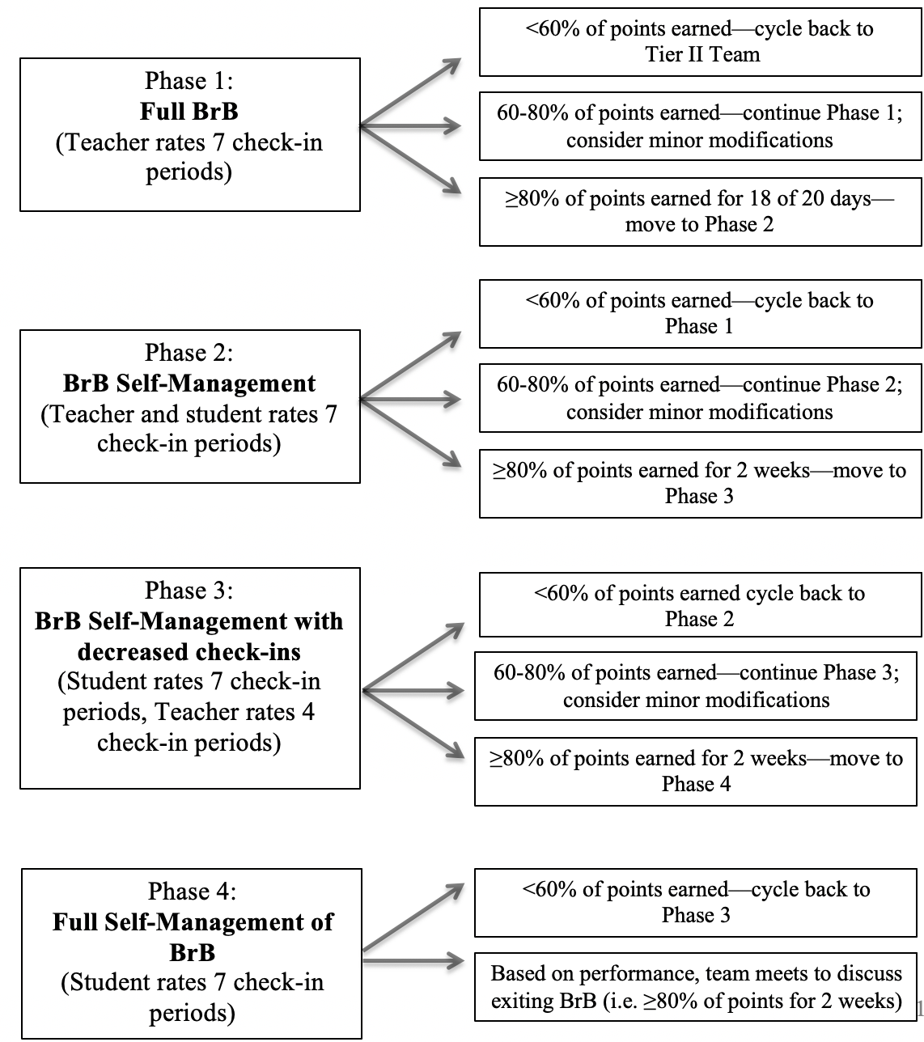

Tier II Intervention Grid
The team used this grid to organize the Tier II interventions offered at our school. This information should be added to the complete intervention grid in the Tier II Implementation Manual.

Support | Logistics |  | Data
Breaks are Better  (BrB) | Description:  brief overview of intervention |  | Entry Criteria:  add any criteria in addition to the Tier II cut-off score grid components  Progress Monitoring Source:  Exit Criteria:  specific exit should be provided or described in the manual of purchased interventions
 | Staff Roles:  list intervention roles | Student Characteristics:  describe who the intervention would fit best
Frequency of Intervention:
number of times per week and/or length of sessions
Adapted from: Lane, K.L., Kalberg, J.R., & Menzies, H.M. (2009). Developing schoolwide programs to prevent and manage problem behaviors a step-by-step approach. New York: Guildford Press.

Training Stakeholders
Our Tier II Team discussed how staff, identified students, and families will be trained on the intervention. The details are listed in the chart below.

Training Staff to Implement the Program
Who will provide instruction to classroom and specialist teachers for implementing the intervention?
Be sure to include:
- Parent role in the BrB program
- Eligibility for participation
- Baseline data collection procedures
- Providing positive and corrective feedback
- Responding to break requests
- Awarding points
- Completing the DPR
- Initiating interactions with students
- Response to major or minor referrals
- Self-management, fading, and graduation
Who will provide teachers with coaching and implementation feedback?
How will re-teaching be provided for components that are not implemented correctly?
Who will provide booster sessions for staff about the purpose and key features of implementing the program? How often will booster sessions occur?

Training Students to Implement the Program
Who will provide instruction about the program to students who are identified for participation?
Be sure to include:
- Purposes of the intervention (e.g., positive, time-limited, goal of self-management)
- When and where to check-in
- Behavioral expectations
- Earning points and point goals
- Entering class and handing the DPR to teachers
- How and when to ask for breaks
- What to do during breaks
- Getting feedback from teachers
- Role play for accepting positive and corrective feedback
- When and where to check-out
- Reinforcers
- How to handle disappointment if goal is not met
- Plans for self-management, fading, and graduation
Consider whether information will be provided to other students about the intervention program. If so, who will provide the information and what will be said?

Training Families to Implement the Program
Who will provide instruction about the program to caregivers of students who are identified for participation?
Be sure to include:
- Purposes of the intervention
- Expectations for student’s daily participation
- Reviewing and signing the DPR
- Consideration of reinforcers provided at home for meeting goals
- Self-management, fading, and graduation
Who will provide re-teaching if caregiver participation is low?
What is the criteria for low participation (e.g., 3 or fewer DPRs returned in a week/month)?

Who will be assigned to act as a pseudo-parent by providing feedback and encouragement to students when parental involvement is low?
List names here:

BrB Implementation Checklist
Use this checklist to determine what your team needs to complete prior to implementing Breaks are Better.

General
- Decide if BrB is right for your school
- Define and assign team member roles (e.g., BrB Coordinator & Data Analyst)
- Assign BrB Mentors
- Identify students in need of intervention
Materials
- Customize BrB Daily Progress Report
- Operationalize Behavioral Expectations on DPR
- Determine available incentives
- Gather available timers
- Create graduation certificate
Breaks
- Finalize Break Routine
- Determine options to track breaks (e.g., “B” cards, marks on DPR)
- Brainstorm potential break options
Progress Monitoring
- Add BrB to Intervention Grid and set decision rules
- Determine fading criteria and graduation
- Decide where DPR data will be entered (e.g., Progress Monitoring Tool)
- Assign who will enter the DPR data
Training Staff, Students, and Parents
- Customize presentation to train staff
- Create plan to train students on all components (e.g., check-in, check-out, teacher feedback, taking breaks, home component)
- Customize scripts to train staff, students, and parents/guardians
- Revise Student Agreement Contract
Identified Students
- Explain BrB to parent/guardian and obtain consent
- Inform student’s teachers and narrow down break option list
- Explain BrB to student, narrow down break option list, complete student contract, and select break routine

Appendix

Notes on updating your Implementation Manual
- The Table of Contents automatically adjusts and reformats according to any changes you make. Use the following steps as a guideline to update page numbers:
  - Click on the title “Table of Contents”
  - A box should appear above where you clicked that says “Table” with an arrow
  - Click on the arrow that appears in the box
  - Click on “Update Table”
  - Click on “Update Page Numbers Only”
  - Click “OK” and the page numbers should update

- Insert the listed items where called for, as indicated by yellow highlights. Delete the highlighted instructions when finished adding the materials. All requested items should be completed during training.

