Implementation Snapshot
Evaluation Feature: Team Composition (1.1)
What is it?
Tier I team includes a Tier I systems coordinator, a school administrator, a family member, and individuals able to provide (a) applied behavioral expertise, (b) coaching expertise, (c) knowledge of student academic and behavior patterns, (d) knowledge about the operations of the school across grade levels and programs, and for high schools, (e) student representation.
Scoring Criteria:  0 = Tier I team does not exist or does not include coordinator, school administrator, or individuals with applied behavioral expertise  1 = Tier I team exists, but does not include all identified roles or attendance of these members is below 80%  2 = Tier I team exists with coordinator, administrator, and all identified roles represented, AND attendance of all roles is at or above 80% | Possible Data Sources/Implementation Products:  - School organizational chart  - Tier I team meeting minutes  - Tier I Implementation Manual
Supporting Implementation
Role of District Coordinator:  - Ensures that school teams consist of the necessary personnel  - Work with coaches and administrators to identify possible staff to fit the different team positions if needed  - Allocate time for teams to attend training  Role of Administrator:  - Identify school staff who represent the necessary team roles  - Attend Tier I team meetings  - Communicate to team members the importance of attending the Tier I team meetings on a consistent basis  - Allocate time for Tier I team meetings  - Work with District Coordinator to allocate time for the Tier I team to attend training  Role of Coach:  - Work with District Coordinator and Administrator to help identify school staff who represent the necessary team roles  - Attend Tier I team meetings  - Attend training with Tier I team | Role of Team:  - Attend Tier I team meetings  - Attend Tier I Training  Role of Staff:  - Participate in PD offered by the Tier I team  - Participate in feedback opportunities provided by the Tier I team  Role of Student, Family, Community  - A student and family member should be on the Tier I team  - Become involved in Parent, Student, Teacher organization
Additional Resources and Research:
Practitioner Resources
- TBSP Materials: Example Tier I Implementation Manual, Example Meeting Foundations Form, Example Agendas
- TBSP Videos: How-To for New Team Members, Advice to Teams starting RTI²-B, RTI²-B Overview Video, RTI²-B Training Walkthrough, RTI²-B Training Walkthrough for High Schools, How Has Your School Seen Change

Research
- How to get PBIS in your school (George, H., & Martinez, S. 2007).
- In search of how principals change A Qualitative Study of Events That Help and Hinder Administrator Support for School-Wide PBIS (Kent McIntosh, Joanna L. Kelm, & Alondra Canizal Delabra,2016)
- School Counselors' Roles in RAMP and PBIS a Phenomenological Investigation (Part Two) (Emily Goodman-Scott, Tim Grothaus, 2018)
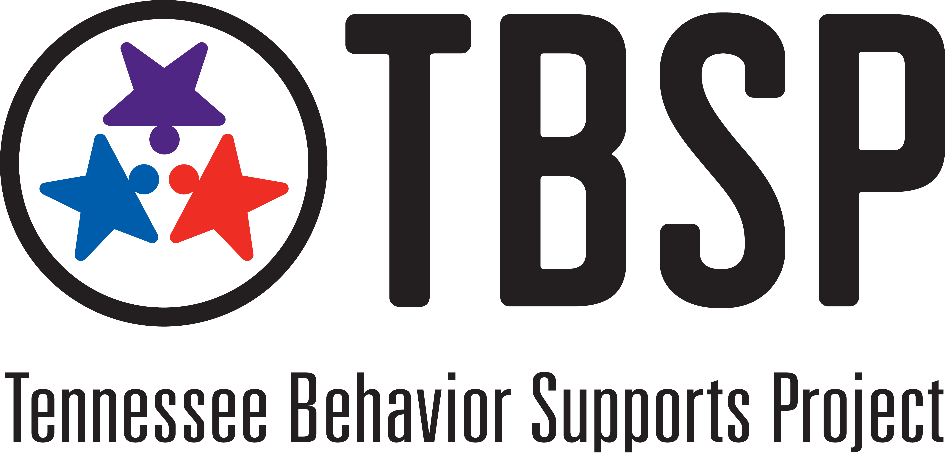
(Adapted from Susan Barrett, Maryland PBIS)

