RTI²-B School Team Workbook
Tier III Training Session 1
School:
District:
Date:
Participants:

Activity #1: How is Tier III Different?
Reflect on Tier I and Tier II training. How do you answer the questions differently in each tier? As a team, complete the table in preparation for a group discussion.

 | Tier I | Tier II | Tier III
Types of interventions?
Which students?
(all, some, few)
Which staff?
How is data used?
What is the impact on problem behavior?

Activity #2: Organizing Your Numbers
With your team, review this table and decide which students your team will: continue to monitor, start Tier II intervention, or refer for Tier III intervention. Be ready to share your answers with the group.

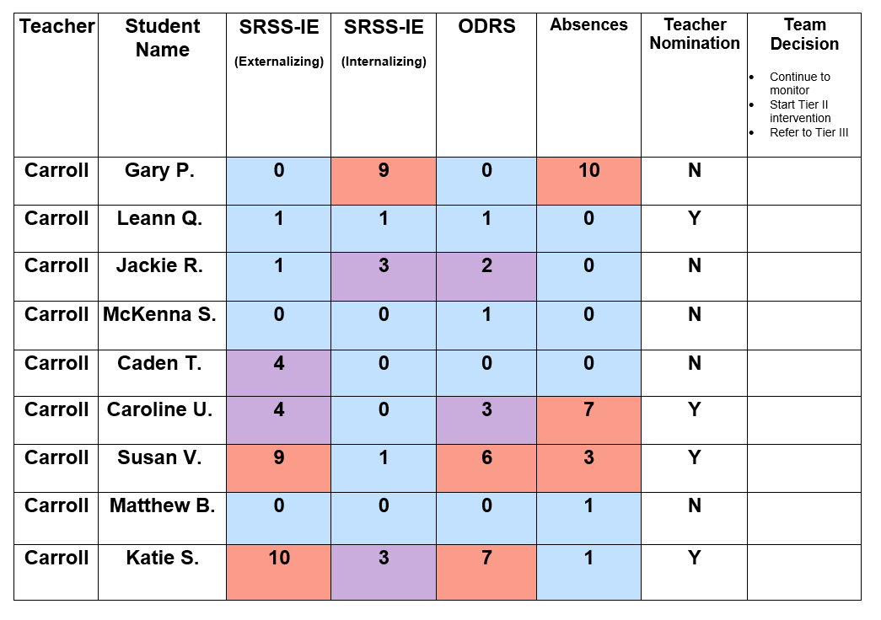

Activity #3: Organizing Your Numbers
Use your school’s enrollment numbers to determine the number of students who could represent each percentage across the three tiers. Fill in the chart below. Then fill in the blanks in the summary box to reflect your school.

School Name: ________________________________
Academic Year: _______________________________

Total Student Enrollment  __________ |  | Our Numbers |  | Our Numbers
 | 3% |  | 5%
 | 10% |  | 15%
 | 80%
At __________________ school, the student population is _____________. We can expect approximately _________ students will be successful with our school’s Tier I practices. Approximately _________ students may need Tier II supports. Finally, it is possible that ________ students may need Tier III supports over the course of the school year.

*Remember these numbers are a National Average and represent what a school could expect when implementing their RTI²-B plan with at least 80% fidelity across all three tiers.

Activity #4: What’s the Function?
Review the function scenarios. Determine the function of each target behavior/scenario with your team. Circle one choice only in the 2nd column and one choice only in the 3rd column for each scenario.
Scenario | Obtain  Avoid  (Circle One) | Tangible Item  Task or Activity  Social Attention  Sensory Stimulation  (Circle One)
Whenever Troy is asked to do independent math work, he tears up his paper and puts his head down. | Obtain  Avoid | Tangible Item  Task or Activity  Social Attention  Sensory Stimulation
Matthew has a difficult time interacting with others. During free time, he typically goes to the space where there are no other people | Obtain  Avoid | Tangible Item  Task or Activity  Social Attention  Sensory Stimulation
Norma loves recess. It is raining so there will be no outside recess today. Upon hearing the news, she screams…and screams…and screams… | Obtain  Avoid | Tangible Item  Task or Activity  Social Attention  Sensory Stimulation
Gilbert loves to tell jokes. During a large group math lesson, he begins to tell a joke while the teacher is talking. The other students in the class laugh at Gilbert. | Obtain  Avoid | Tangible Item  Task or Activity  Social Attention  Sensory Stimulation

Session 1 Homework Checklist and Action Plan:
Action Item: | Who? | By When? | Notes:

