Graphing Template Guide for Excel
Weekly Rate Chart
- Locate your rate data sheets
- Open your Graphing Template Excel file and click tab labeled “Rate Data”
- Enter student’s name in title of page, as well as box labeled “Student name”
- Enter student‘s target behavior in title of page
- Enter target behavior in white box labeled “Enter target behavior here”
- Enter date ranges (example: 8/27-8/31) for baseline and/or intervention in boxes labeled “Enter date range”
- List dates data was collected next to appropriate session number
- Fill in rates under either baseline or the appropriate intervention
- Averages will automatically be calculated at the bottom and above each column
- Click tab labeled “Rate Graph” to review graph
Weekly Duration Chart
- Locate your duration data sheets
- Open your Graphing Template Excel file and click tab labeled “Duration Data”
- Enter student’s name in title of page, as well as box labeled “Student name”
- Enter student’s target behavior in title of page
- Enter target behavior in white box labeled “Enter target behavior here”
- Enter date ranges (example: 8/27-8/31) for baseline and/or intervention in boxes labeled “Enter data range”
- List dates data was collected next to appropriate episode number
- Fill in duration in minutes under either baseline or the appropriate intervention
- Averages will automatically be calculated at the bottom and above each column
- Click tab labeled “Duration Graph” to review graph
Time Sampling
- Locate your time sampling data sheets
- Open your Graphing Template Excel file and click tab labeled “Time Sampling Data”
- Enter student’s name in title of page, as well as box labeled “Student name”
- Enter student’s target behavior in title of page
- Enter target behavior in white box labeled “Enter target behavior here”
- Enter date ranges (example: 8/27-8/31) for baseline and/or intervention in boxes labeled “Enter data range”
- List dates data was collected next to appropriate session number
- Fill in number of intervals you selected “yes” and total intervals observed
- Percent intervals “Yes” will automatically be calculated
- Baseline and Intervention averages will automatically be calculated at the bottom and above each column
- Click tab labeled “Time Sampling Graph” to review graph

Direct Behavior Rating
- Locate your direct behavior rating data sheets
- Open your Graphing Template Excel file and click tab labeled “DBR Data”
- Enter student’s name in box labeled “Student name”
- Enter target behavior in white box labeled “Enter target behavior here”
- Enter date ranges (example: 8/27-8/31) for baseline and/or intervention in boxes labeled “Enter date range”
- List dates data was collected next to the appropriate session number
- Fill in target behavior ratings and replacement behavior ratings
- Column averages will be automatically calculated at the bottom and above each column
- Click tab labeled “DBR Graph” to review graph

General Tips for Graphing
How to add a line for a phase change
- Click “Insert”
- Then “Shapes”
- Select the line shape
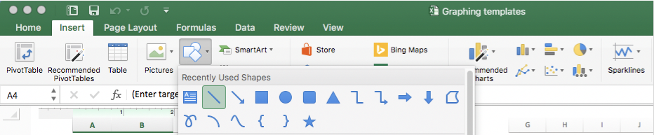
- Click and drag where you would like to place the phase change line
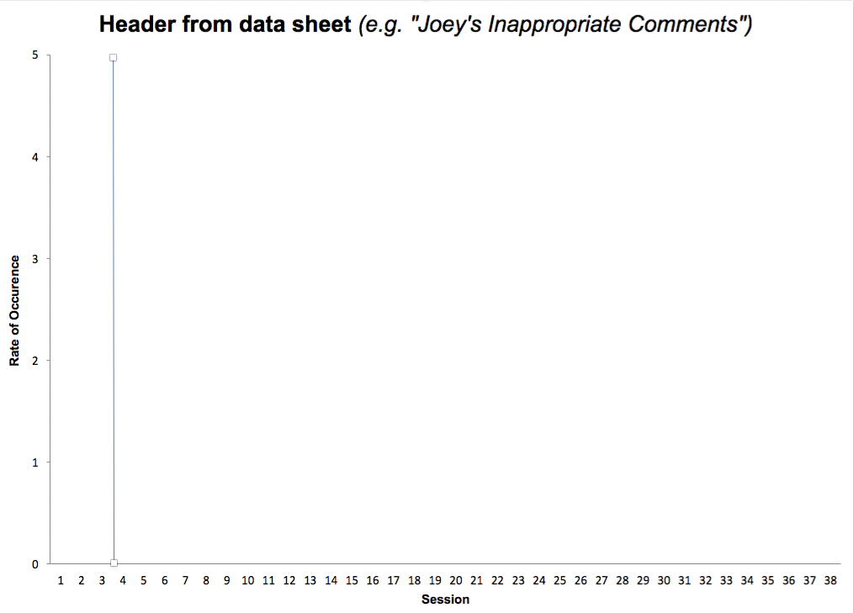

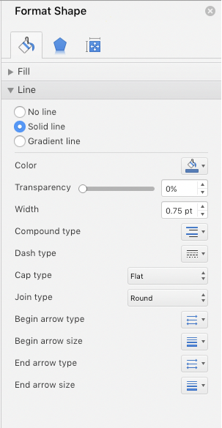
How to format a phase change line
- The color and width of the line can be changed by
right clicking the line and selecting “format shape”
- Under “Line”, select “Solid line”
- To change the color, click the paint can and select a color
- To change the width, type in the number and press
enter or use the arrows
- To change the dash type of the line, click the down arrow
and select a dash type you would like

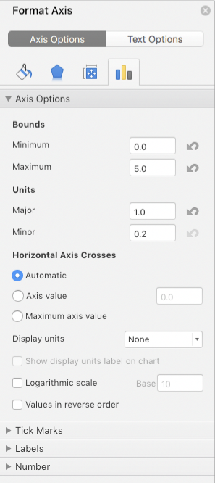
How to format the graph axis
- Right click the axis that needs to be formulated
and select “Format axis”
- Use the menu to adjust units, display values, add
tick marks, position labels, and format the numbers

How to add a trend line
- Click “Chart Design” from the top green menu
- Click “Add Chart Element”
- Select “Trendline”, then “Linear”

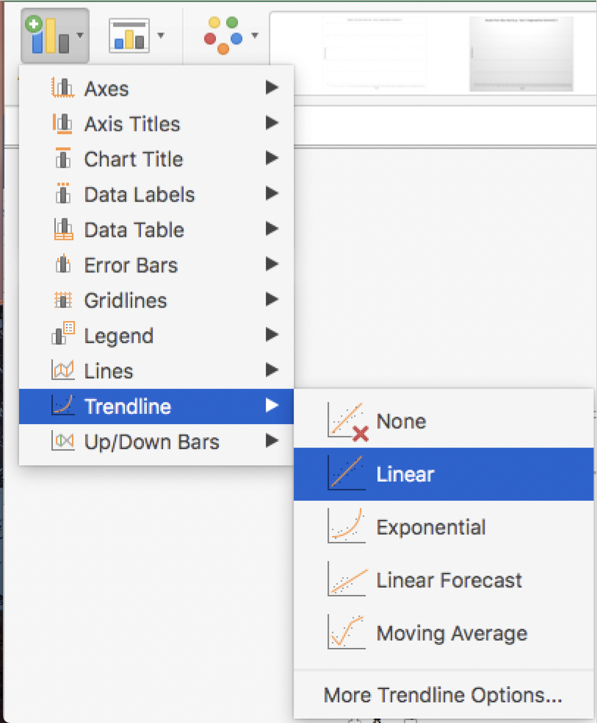

How to edit title of graph title or axis labels
- Click on text box
- Backspace and type preferred graph title/axis labels
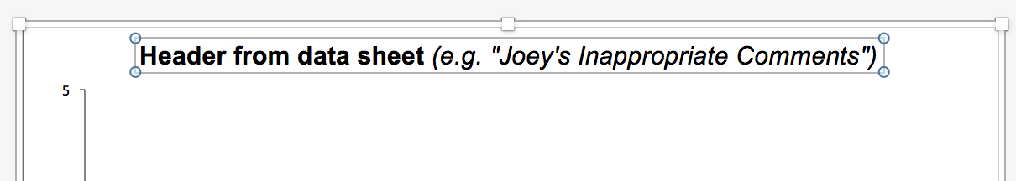

How to adjust number ranges on graph
- Right-click on axis
- Select “Format Axis”
- “Axis Options” column should appear on right-hand side of document
- Adjust minimum/maximum or minor/major by entering them
