

1ST QUARTER DATA

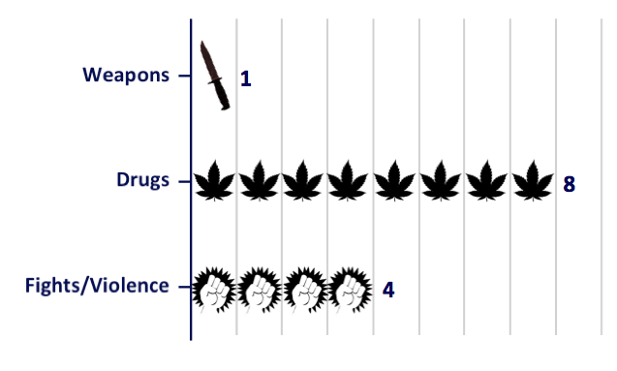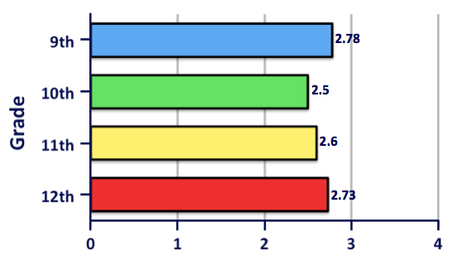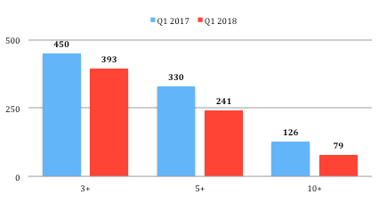

Major Referrals for October

1st Quarter Tardies

Number of Students

**October: 120**

**YTD: 248**

Main Office/Fine Arts: 18

Social Studies/Counseling: 3

English/Business: 7

Math/Health/P.E.: 11

Science/World Language: 24

SPED/CTE: 57

Colt Compliment Cards for October

October Q1 Overall

October Q1 Overall

October Q1 Overall

October Q1 Overall

67%

60%

73%

67%

78%

69%

85%

78%

October: 5

YTD: 19

Staff Compliment Cards for October

12th Grade

11th Grade

10th Grade

9th Grade

At Least 90% Attendance

1st Quarter Average GPA

Campus Climate Team 2018