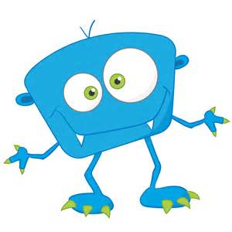**Lesson Plan Passport**

Bathroom

Cafeteria

Playground

Hallway

Classroom

Assemblies

**INSIDE PAGES**

MNS Leader Expectation Passport

Name_____________

Grade____________

Teacher_________

Be a Respectful Leader!

Be a Responsible Leader!

Be a Safe Leader!

Arrival/

Dismissal

**FRONT PAGE**

**BACK PAGE**