Middle School Expectation Matrix

 | Settings
Expectations | Classroom | Hallway | Cafeteria | Restroom | Bus | Arrival/Dismissal
Respect | - Following directions and procedures quickly  - Demonstrate self-control  - Cooperate with others  - Keep hands, feet and objects to yourself  - Listen, respect and pay attention to the speaker  - Respect others work and material  - Appropriate responses to adults and peers at all times | - Stay calm and controlled in conflict with adults and peers  - Be courteous of other classrooms  - Respect student work/materials  - Keep hands and feet to yourself  - Refrain from PDA  - Use appropriate language | - Listen to and follow adult requests  - Follow directions the first time asked, talk in normal voice levels  - Keep food on your plate  - Clean up after yourself | - Give others privacy and personal space  - Keep surfaces free of graffiti | - Get to the bus in a timely manner  - Listen to and follow the bus drivers rules  - Remain seated after entering the bus  - Stay clear of driveways and roadways | - Respond immediately when teachers/adults call  - Control temper in conflict situations  - Follow all procedures
Responsibility | - Be present and prepared  - Turn in finished work  - Exercise self-control  - Ask questions as needed  - Make-up work when absent according to county policy  - Report any problems to your teacher | - Report unsafe behaviors immediately  - Follow instructions given for drills and emergencies  - Keep your hands and feet to yourself  - Use appropriate language  - Report any problems to your teacher  - Must have agenda  - Keep on your side of stairs  - Keep personal belongings in locker  - Keep hallways clean | - Clean up after yourself  - Clear away trash  - Eat lunch  - Choose a seat quickly and stay in it  - No food or drink taken from cafeteria  - Report any problems to your teacher  - Keep doorways clear of back packs | - Report any problems to your teacher (graffiti, fighting, horseplay, etc.)  - Use restroom quickly, and utilize the time between classes  - Return to classroom promptly and quietly | - Remain in seat  - Use self- control  - Keep head and hands inside the bus  - Keep hands and feet to yourself | - Arrive on time to school  - Bring to school and take home all necessary materials  - Report any problems to your teacher  - Stay in designated areas until dismissed
Best Effort | - Participate in classroom activities  - Complete work with best effort  - Remain on-task  - Show a positive attitude  - Stay focused on your own work  - Come to class with a focus on learning | - Pay attention to where you’re going  - Use hallway time appropriately and efficiently  - Clear hallway one minute before class | - Clear away trash  - Eat lunch  - Use appropriate table manners | - Respond appropriately to conflict situations  - Keep restrooms clean | - Stay clear of the moving bus  - Keep hands and feet to yourself | - Resolve conflicts peacefully  - Show a positive attitude

 | CLASSROOM | HALLWAYS | BUS | BATHROOMS | LIBRARY
Honesty | - Be honest with yourself  - Speak up when you don’t understand  - Do your own work  - Say what you’ll do and do what you say  - Keep your cell phone off and put away | - Take responsibility for your actions  - Know only your own locker combination  - Keep your cell phone off and put away | - Take responsibility for your actions  - Keep yourself and belongings in your own space | - Go directly to the bathroom and return to your class promptly  - Keep your cell phone off and put away | - Check out all materials prior to leaving the library  - Use computers for school projects only
Optimism | - Always show your best attitude  - Expect to be successful  - Strive to do your best  - Be open to all learning possibilities  - Treat others with kindness and respect | - You can get to class in three minutes  - Smile!  - Be positive about your day  - Treat others with kindness and respect | - Be positive about your day  - Treat others with kindness and respect | - You can use the bathroom in a timely manner  - Treat others with kindness and respect | - Recommend new book titles to the librarian and others  - Treat others with kindness and respect
Respect | - Respect school property and equipment  - Allow others the best opportunity to learn  - Be nice  - Use appropriate language and voice level | - Respect others and their property  - Respect school property  - Use appropriate language and voice level | - Respect others and their property  - Respect school property  - Listen to driver  - Use appropriate language and voice level | - Respect school property  - Respect others privacy  - Wash hands properly  - Use appropriate language and voice level | - Respect library staff and resources  - Return materials promptly  - Follow library rules  - Use appropriate language and voice level
Determination | - Dedicate yourself to being on time  - Keep trying even when it’s difficult  - Seek help when needed  - Set goals and strive to reach them | - Dedicate yourself to being on time; move promptly  - Strive to keep a clean and tidy locker | - Dedicate yourself to being on time  - Stay seated and face forward | - Be determined to be in class  - Schedule bathroom breaks wisely | - Seek help when needed  - Remain focused on your task
Excellence | - Extend yourself beyond the minimum; effort counts  - Push yourself to be what you want to be  - Organize and prioritize  - Develop your study skills | - Use a hallway pass/agenda when needed  - Walk slowly and safely at all times  - Keep to the right | - Walk slowly and safely at all times  - Keep aisle clear  - Be a good role model | - Keep bathroom clean  - Use a hallway pass/agenda when needed  - Report problems | - Be helpful  - Be a good role model

 | CAFETERIA | ASSEMBLY AREAS | OFFICE | ATHLETIC EVENTS
Honesty | - Begin at the end of the line and stay in line  - Sign-out before leaving and have a pass  - Keep your cell phone off and put away | - Sit in appropriate areas  - Remain with your group  - Keep your cell phone off and put away | - State your name and purpose upon entering the office  - Be honest about the purpose of your visit  - When business is done, move on | - Be responsible for your actions  - Be positive toward all players, coaches, officials, and spectators
Optimism | - Be positive about your day  - Treat others with kindness and respect | - Show appropriate enthusiasm  - Keep remarks and gestures positive and polite | - Be positive about your day  - Be part of the solution | - Show appropriate enthusiasm  - Keep remarks and gestures positive and polite  - Treat others with kindness  - Support teams enthusiastically
Respect | - Respect school property  - Return trays, dishes, and utensils  - Use appropriate language and voice level | - Respect school property  - Give the presenter your full attention  - Sit in an appropriate fashion  - Cooperate with all adult requests | - Maintain a quiet working environment  - Present issues individually | - Use appropriate language and voice level  - Respect visiting team and spectators  - Respect school property  - Adhere to the code of conduct for spectator behavior
Determination | - Dedicate yourself to being on time  - Remain seated and at your table  - Practice healthy eating habits | - Dedicate yourself to being on time  - Remain seated | - Practice patience; wait your turn  - Conduct business in a timely manner | - Sit in appropriate areas and remain seated
Excellence | - Walk slowly and safely at all times  - Place trash in trash bins  - Use recycle areas | - Approach assemblies with an open mind  - Enter and exit in a quiet, orderly fashion | - Be polite; remember please and thank you  - Take responsibility for actions and accept consequences graciously | - Enter and Exit at appropriate times  - Accepting winning and losing graciously

MUSTANG PRIDE | SHOW RESPECT | ACT RESPONSIBLY | TAKE PRIDE
In the classroom, Mustangs... | - Follow directions  - Cooperate with others  - Listen and pay attention to the speaker | - Remain in classroom the entire class period  - Bring your required materials  - Turn in finished work, including work from absences  - Exercise self-control | - Participate in class activities  - Complete work with best effort  - Remain on task  - Use time wisely
On buses and in cars, Mustangs... | - Use quiet voices  - Use appropriate/positive words and actions  - Speak to others in a polite manner | - Listen to directions  - Get to your car/bus quickly and safely  - Keep hands, feet, and objects to self  - Report problems to the bus driver | - Keep belongings to self  - Clean up after yourself  - Know your bus number and driver’s name  - Be a positive representative of Spring Station Middle School
In the cafeteria, Mustangs... | - Use quiet voices  - Follow directions  - Say please and thank you to staff  - Walk to and from lunch quietly | - Know your lunch number  - Stay in your assigned seat  - Handle food as it is meant to be handled  - Get all items the first time | - Throw trash in garbage  - Clean up your area (wipe tables and sweep floor)  - Stake your trays appropriately
In the restroom, Mustangs... | - Respect everyone’s private space | - Use proper washing habits (soap, water, paper towels)  - Keep classroom materials out  - Report any problems or misbehaviors to staff | - Flush toilet  - Keep floor clean of paper and water
In the hallways, stairwells, and at the lockers, Mustangs... | - Be kind to your locker neighbor  - Use quiet voices  - Keep your belongings in your locker | - Get your materials quickly and move on  - Refrain from horseplay  - Walk with the flow of traffic  - Stay on the right side of the hall and stairwells | - Keep the floors clean (even if it’s not yours, pick it up)  - Arrive on time to class  - Keep your lockers closed and locked
In the library and the computer lab, Mustangs... | - Use quiet voices  - Are kind to library books, computers, and furniture | - Bring agenda for checkout  - Return unwanted books to circulation desk for re-shelving  - Know that computers are for academic use ONLY | - Clean up after yourself  - Keep food and drinks out of the library and computer lab
At assemblies, Mustangs... | - Listen to and follow directions  - Sit with assigned teacher | - Enter quickly and quietly  - Keep hands and feet to self  - Load from bottom up; unload from top down | - Show appropriate school spirit  - Stay positive

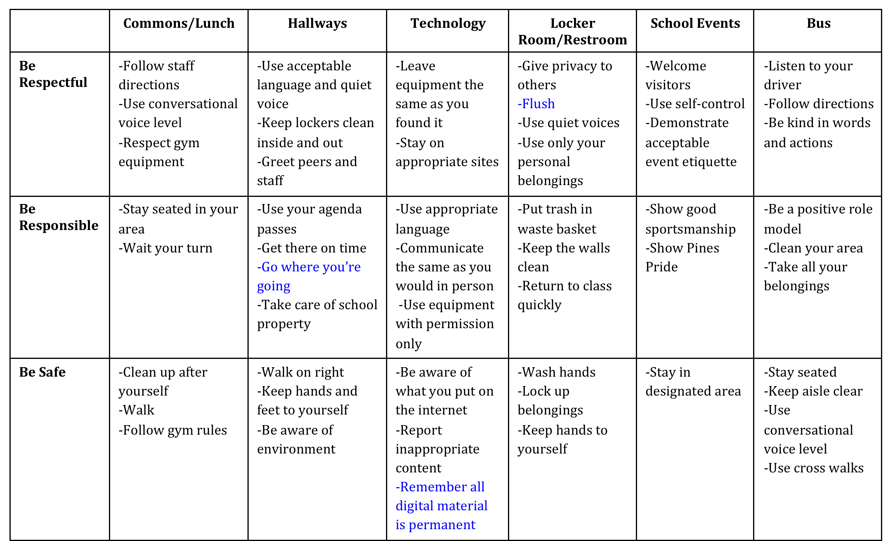
PINES PRIDE Expectations Matrix

LOCATIONS
CORNERSTONE
EXPECTATIONS | All  Classrooms | Hallway | Cafeteria | Restroom | Bus | Playground/  Gym | Assembly
PREPARED | -Uniform in place  -Arrive on time  -Have materials | -Uniform in place  -Have hall pass if alone | -Collect all items before sitting  -Know lunch number | -Have pass when needed  -Wait your turn  -Bring book | -Arrive on time  -Have all materials | -Uniform in place  -Use equipment as instructed | -Bring required items
RESPECTFUL | -Follow directions  -hands feet to self  -raise hand for permission  -Follow voice level cue | -Face forward  -hands/feet to self  -Voice level 0 | -Raise hand for help  -Follow voice level cue  --Say please and thank you  -Hands, feet to self | -Voice level 0  -One per stall/sink  -Hands, feet to self  -Uniform in place  before exiting | -Voice level 1  -Follow directions  -Hands,feet to self | -Hands, feet to self  -Voice level 0 when in line | -Enter/exit voice level 0  -Listen  -Raise hand for help  -Follow directions  -Hands, feet to self
ENGAGED | -Respond when spoken to  -Follow voice level cue | -Follow directions  -Walk on right | -Line-up when called with voice level 0 | -Read while waiting | -Listen  -Watch for stop | -Listen  -Follow instructions  -Say “I’m sorry”, “thank-you” when needed | -Show support when prompted  -Watch for voice level cue  -Participate when prompted
PURPOSEFUL | -Complete task on time  -Store supplies in designated location | -Two blocks separation | -Eat first, then talk  Voice level 1  -Place trash in bin when prompted | -Wash hands  -Turn off faucet  -Place trash in bin  -Report issues to teacher | -Walk directly to seat  -Stay seated  -Face forward | -Return equipment to designated location  -Line-up when called | -walk
 | H  Have Respect | A  NH HAWKS  Act Responsibly | W  Work Together | K  Keep Safe
On the  BUS | *Listen  *Voice level 1 | *Be on time  *Report problems | *Load and unload as directed  *Stay in seat | *Keep aisle clear  *Back to back  *Seat to seat  *Feet on the floor
During  ARRIVAL | *Enter voice level 1 | *Be on time | *Go directly to assigned location | *Walk on the right
In the  HALLWAY | *Voice Level 1  *Close lockers gently | *Go directly to location  *Report any problems  *Only use your locker | *Listen for teacher directions *trash free zone | *Walk on the right  *Hands and feet to self
In the  RESTROOM | *Voice level 1  *Honor privacy | *Flush  *Wash hands with soap  *Complete business then  leave  *Place trash in can | *Wait your turn for sink  *Keep water in sink  *Listen for teacher’s  directions | *Hands and feet to self  *Report problems to teacher
All  CLASSES | *Listen  *Watch for voice level cue | *Complete assigned task  *Arrive on time  *Have needed supplies | *Follow teacher direction  *Place trash in can | *Walk  *Use materials as directed  *Hands and feet to self
In the  CAFETERIA | *Eat with utensils  *Eat only your food  *Eat then talk | *Raise hand for help  *Get needed items before sitting  *Stay seated until called | *Watch for voice level cue  *Know lunch number | *Walk  *Keep feet under the table  *Hold tray with two hands
During  DISMISSAL | *Listen for announcements  *Hands and feet to self | *Go directly to assigned location  *Have belongings packed and ready | Watch for voice level cue | *Follow adult directions

Bramble School Expectations
 | BE SAFE | BE RESPECTFUL | BE PREPARED
CAFETERIA | -Wait in line for your turn  -Walk in and out of the cafeteria | -Speak at an appropriate volume  -Follow adult directions  -Show good table manners  -Have appropriate conversations with your friends | -Throw away your trash and recycle plastic bottles  -Clean your area after eating  -Stay at your designated area
TECHNOLOGY | -Visit school appropriate sites only  -Report inappropriate content  -Use equipment with care and obtain permission before using | -Leave equipment the same as you found it  -Speak at an appropriate volume | -Keep food and drinks away from computers  -Use technology for academic purposes only
HALLS | -Walk with your feet moving in the flow of traffic; stay on the right side of the hall and stairs | -Keep hands off walls and pick up trash  -Keep hands to self  -Use quiet voices  -Follow adult directions | -Go directly to where you need to go  -Be efficient and arrive to class on time
ARRIVAL/  DEPARTURE | -Respond immediately when teachers/adults call  -Stay in designated area  -Walk both inside and outside of school grounds | -Speak at an appropriate volume both inside and outside of school building  -Resolve conflicts with others | -Arrive on time  -Go directly to destination
CLASSROOM | -Keep hands, feet, and objects to yourself  -Appropriate responses to adults and peers at all times | -Pay attention to the speaker  -Follow directions  -Work well with others | -Complete all classwork  -Be present with all materials ready  -Ask questions as needed
RESTROOM | -Keep restrooms clean  -Report any problems or misbehaviors to staff (graffiti, fighting, horseplay, bullying, etc.) | -Honor privacy  -Wait patiently for your turn  -Keep restrooms clean | -Use restroom quickly, and use the time between classes  -Return to classroom promptly and quietly  -Use soap and water for washing hands
GYM/PE | -Use equipment appropriately  -Keep hands, feet and objects to yourself | -Follow teacher directions  -Use appropriate language and tone | -Put equipment away  -Be on time and present
BUS | -Stay in your seat  -Keep your hands, feet, and objects to yourself  -Report any misbehavior to staff | -Use a quiet voice  -Follow bus driver directions  - Use appropriate language | -Get to bus on time  -Walk on and off quickly  -Clean up after yourself
ASSEMBLIES/  SPECIAL EVENTS | -Listen to adult directions  -Sit in assigned area | -Stay positive  -Use appropriate volume | -Enter quickly and quietly  -Listen while speakers are talking

