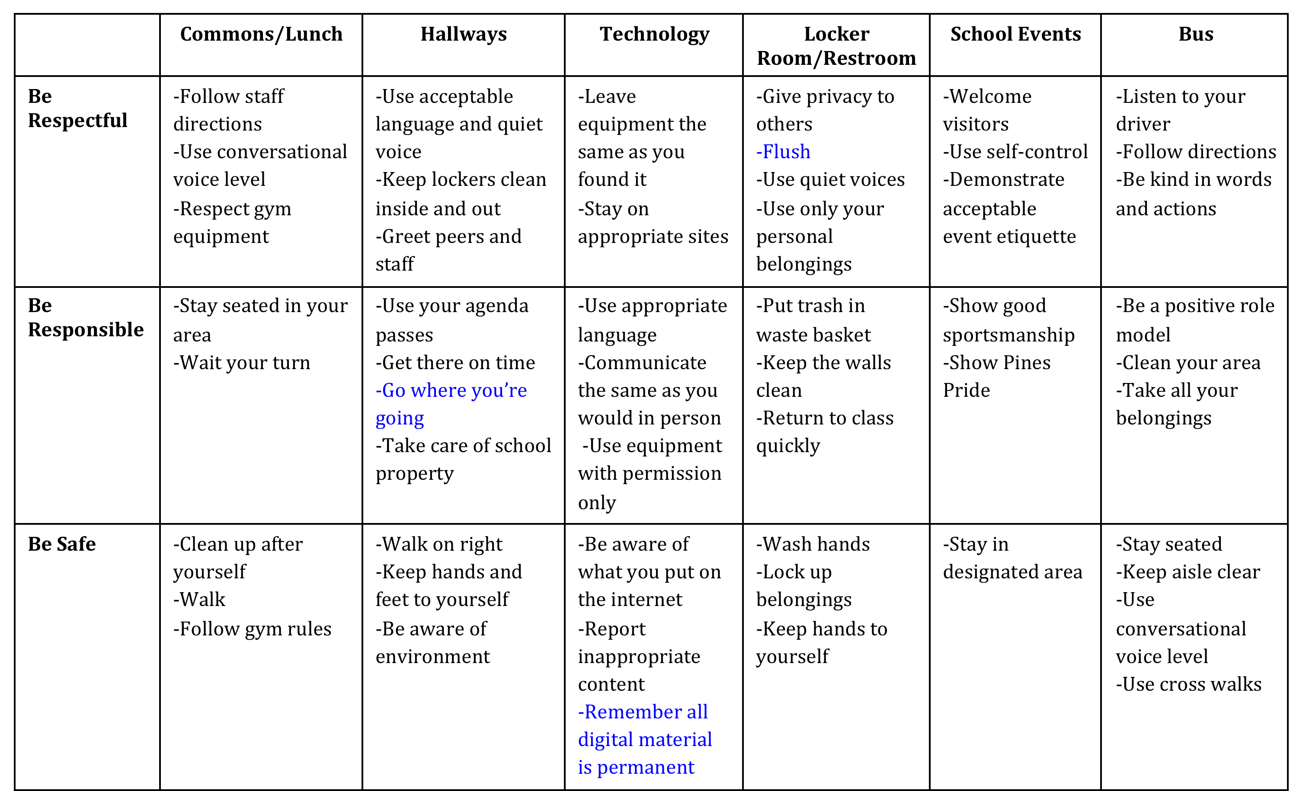
PINES PRIDE Expectations Matrix
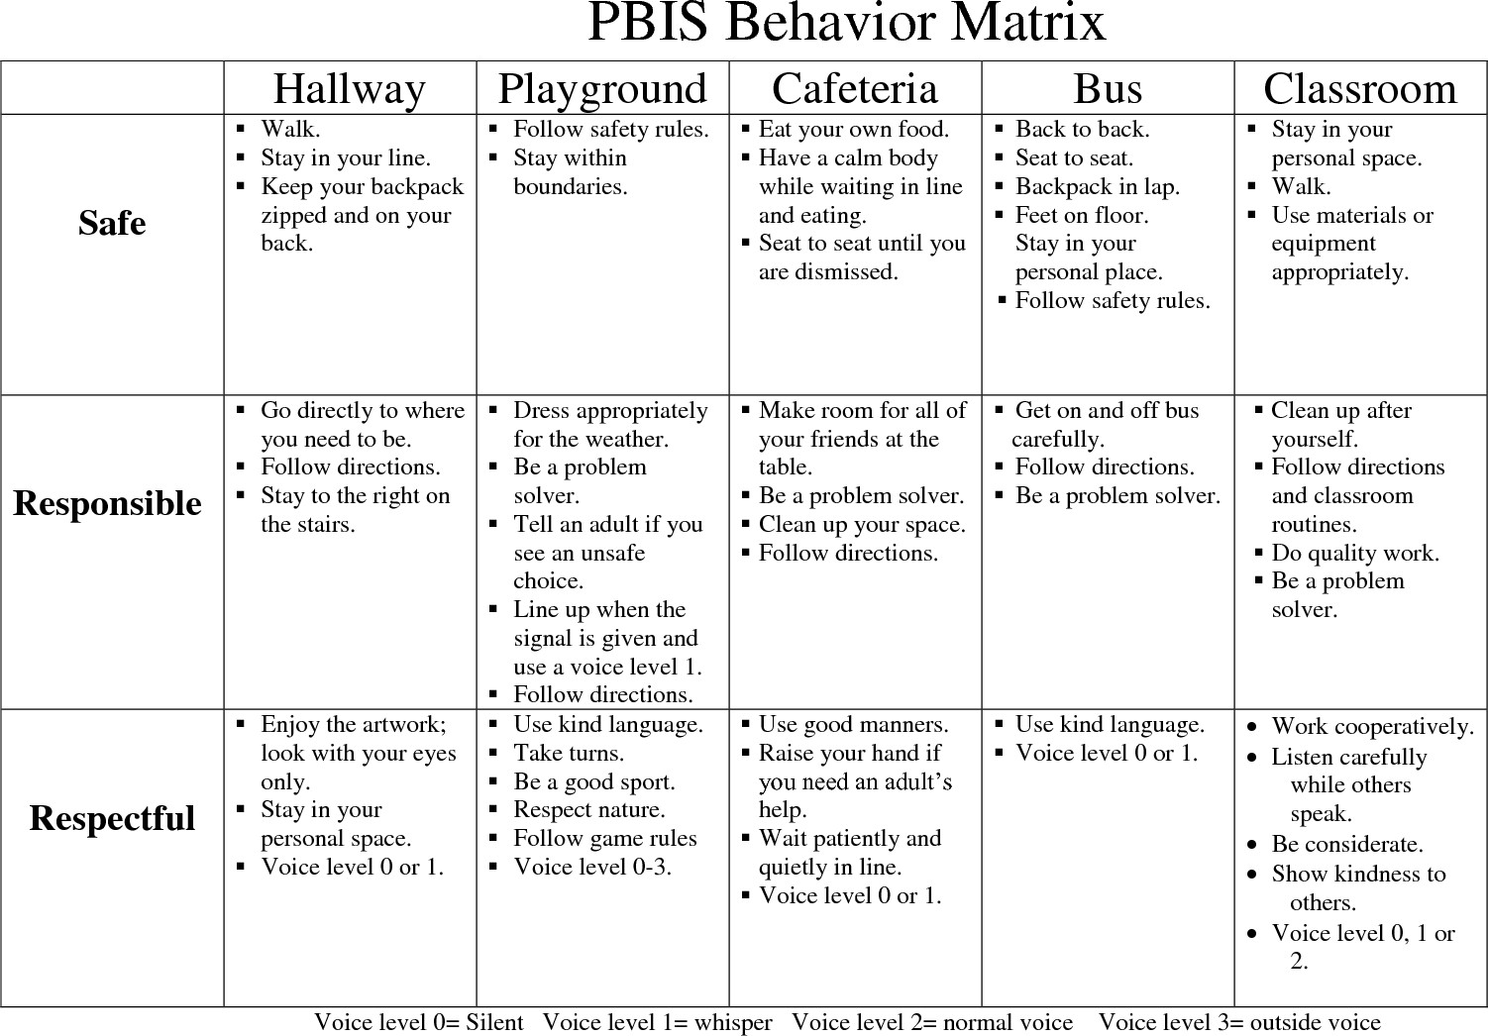

Expectations | Classroom | Hallway | Cafeteria | Playground | Restroom | Bus | Arrival | Dismissal
Be Respectful | * Follow directions  * Listen to speaker  *Keep hands and feet to self  * Use kind words and  actions | * Be courteous of others  * Keep hands/feet to self  * Respect materials | * Listen to/follow adult requests  * Follow directions the first time asked | * Respond immediately when teacher/adult calls  * Be kind to peers while playing games | * Privacy issues  * Knock first  * No playing | * Listen and follow rules  * Remain seated  * Stay clear of roadway | * Respond immediately to teacher/  staff on duty | * Respond immediately to teacher
Be Responsible | *Exercise self-control  * Use time wisely  * Take care of school property  *Turn in finished work | * Follow directions given for drills/ emergencies  * Walk  * Report unsafe behavior | * Clean up after yourself  * Raise hand for permission to get up | * Stay in established area  * Report problems/  unsafe behaviors to teacher | * Flush  * Wash hands  * Throw away trash  * Report problems | * Remain in seat  * Use self-control  * Be ready when bus arrives | * Keep all materials in backpack  * Arrive on time  * Go straight to class or cafeteria if eating | * Keep all materials in backpack  *Stay in assigned area
Give Best Effort | * Complete work to your best effort with a positive attitude  * Remain on task, participate in class activity | * Walk directly to next location  * Pay attention to where you are going  *Walk quietly | * Eat lunch  * Use your table manners | * Control your temper  * Include others in your activities | * Keep clean  * Personal cleanliness | * Keep hands and feet to self  * Be sure you get all your personal belongings and trash | * Positive attitude  * Patience | * Positive attitude  * Patience

LOCATIONS
EXPECTATIONS | All  Classrooms | Hallway | Cafeteria | Restroom | Bus | Playground/  Gym | Assembly
PREPARED | -Uniform in place  -Arrive on time  -Have materials | -Uniform in place  -Have hall pass if alone | -Collect all items before sitting  -Know lunch number | -Have pass when needed  -Wait your turn  -Bring book | -Arrive on time  -Have all materials | -Uniform in place  -Use equipment as instructed | -Bring required items
RESPECTFUL | -Follow directions  -hands feet to self  -raise hand for permission  -Follow voice level cue | -Face forward  -hands/feet to self  -Voice level 0 | -Raise hand for help  -Follow voice level cue  --Say please and thank you  -Hands, feet to self | -Voice level 0  -One per stall/sink  -Hands, feet to self  -Uniform in place  before exiting | -Voice level 1  -Follow directions  -Hands,feet to self | -Hands, feet to self  -Voice level 0 when in line | -Enter/exit voice level 0  -Listen  -Raise hand for help  -Follow directions  -Hands, feet to self
ENGAGED | -Respond when spoken to  -Follow voice level cue | -Follow directions  -Walk on right | -Line-up when called with voice level 0 | -Read while waiting | -Listen  -Watch for stop | -Listen  -Follow instructions  -Say “I’m sorry”, “thank-you” when needed | -Show support when prompted  -Watch for voice level cue  -Participate when prompted
PURPOSEFUL | -Complete task on time  -Store supplies in designated location | -Two blocks separation | -Eat first, then talk  Voice level 1  -Place trash in bin when prompted | -Wash hands  -Turn off faucet  -Place trash in bin  -Report issues to teacher | -Walk directly to seat  -Stay seated  -Face forward | -Return equipment to designated location  -Line-up when called | -walk

 | H  Have Respect | A  NH HAWKS  Act Responsibly | W  Work Together | K  Keep Safe
On the  BUS | *Listen  *Voice level 1 | *Be on time  *Report problems | *Load and unload as directed  *Stay in seat | *Keep aisle clear  *Back to back  *Seat to seat  *Feet on the floor
During  ARRIVAL | *Enter voice level 1 | *Be on time | *Go directly to assigned location | *Walk on the right
In the  HALLWAY | *Voice Level 1  *Close lockers gently | *Go directly to location  *Report any problems  *Only use your locker | *Listen for teacher directions *trash free zone | *Walk on the right  *Hands and feet to self
In the  RESTROOM | *Voice level 1  *Honor privacy | *Flush  *Wash hands with soap  *Complete business then  leave  *Place trash in can | *Wait your turn for sink  *Keep water in sink  *Listen for teacher’s  directions | *Hands and feet to self  *Report problems to teacher
All  CLASSES | *Listen  *Watch for voice level cue | *Complete assigned task  *Arrive on time  *Have needed supplies | *Follow teacher direction  *Place trash in can | *Walk  *Use materials as directed  *Hands and feet to self
In the  CAFETERIA | *Eat with utensils  *Eat only your food  *Eat then talk | *Raise hand for help  *Get needed items before sitting  *Stay seated until called | *Watch for voice level cue  *Know lunch number | *Walk  *Keep feet under the table  *Hold tray with two hands
During  DISMISSAL | *Listen for announcements  *Hands and feet to self | *Go directly to assigned location  *Have belongings packed and ready | Watch for voice level cue | *Follow adult directions

Example Behavioral Expectations Matrix

Expectations | Classroom | Hallway | Cafeteria | Recess | Restroom | Gym | Bus | Arrival/ Departure | Assemblies/  Special Events
Respect | Listen to speaker  Wait your turn | Keep hands off walls  Be quite in halls and commons | Use an inside talking voice  Use a napkin to clean self and spills | Practice good sportsmanship  Take turns and share equipment | Honor privacy  Wait patiently for your turn | Follow teacher directions | Use a quiet voice  Follow bus driver directions | Follow directions of Safety Patrol members  Wait with a calm body and quiet voice in line | Sit quietly
Responsibility | Follow class rules at all times  Finish Work | Go directly to where you need to go  Look to your teacher for directions | After getting lunch & utensils, choose a seat and stay there  Dump tray & recycle milk carton | Line up when the bell rings  Put equipment away | Flush toilet after use  Use quickly, then leave | Put equipment away | Get to bus on time  Walk on and off quickly | Be on time  Go directly to destination | 4 A’s of Audience: Attend Appreciate Applaud Allow
Safety | Keep hands, feet, and objects to self  Walk | Stay with line Walk | Hold tray with 2 hands  Keep food to self without sharing | Use equipment appropriately  Keep hands and feet to self | Use soap & water to wash hands  Keep restrooms clean and dry | Use equipment appropriately  Keep hands and feet to self | Stay in seat  Keep hands, feet, and objects to self | Cross only at crosswalk even when adults are present  Walk inside & outside on school grounds | Sit correctly on floor (criss- cross applesauce)  Keep hands and feet to self

Expectations | Classroom | Hallway | Cafeteria | Recess | Restroom | Gym | Bus | Arrival/  Departure | Assemblies/  Special Events
Respect | Listen to speaker  Wait your turn | Keep hands off walls  Be quite in halls and commons | Use an inside talking voice  Use a napkin to clean self and spills | Practice good sportsmanship  Take turns and share equipment | Honor privacy  Wait patiently for your turn | Follow teacher directions | Use a quiet voice  Follow bus driver directions | Follow directions of Safety Patrol members  Wait with a calm body and quiet voice in line | Sit quietly
Responsibility | Follow class rules at all times  Finish Work | Go directly to where you need to go  Look to your teacher for directions | After getting lunch & utensils, choose a seat and stay there  Dump tray & recycle milk carton | Line up when the bell rings  Put equipment away | Flush toilet after use  Use quickly, then leave | Put equipment away | Get to bus on time  Walk on and off quickly | Be on time  Go directly to destination | 4 A’s of Audience:  Attend  Appreciate  Applaud  Allow
Safety | Keep hands, feet, and objects to self  Walk | Stay with line  Walk | Hold tray with 2 hands  Keep food to self without sharing | Use equipment appropriately  Keep hands and feet to self | Use soap & water to wash hands  Keep restrooms clean and dry | Use equipment appropriately  Keep hands and feet to self | Stay in seat  Keep hands, feet, and objects to self | Cross only at crosswalk even when adults are present  Walk inside & outside on school grounds | Sit correctly on floor (criss-cross applesauce)  Keep hands and feet to self

 | BE SAFE | BE RESPECTFUL | BE RESPONSIBLE
CAFETERIA | -Hold tray with 2 hands  -Keep food to self without sharing | -Use an inside talking voice  -Use a napkin to clean self and spills | -After getting lunch and all utensils, choose a seat and stay there  -Dump tray and recycle milk carton in appropriate place
RECESS | -Use equipment appropriately  -Keep hands and feet to self | -Practice good sportsmanship  -Take turns and share equipment | -Line up when the bell rings  -Put equipment away
HALLS | -Stay with line  -Walk | -Keep hands off walls  -Be quiet in halls and commons | -Go directly to where you need to go  -Look to your teacher for directions
ARRIVAL/  DEPARTURE | -Cross only at cross walk even when adults are present  -Walk inside and outside on school grounds | -Follow directions of Safety Patrol members  -Wait with a calm body and quiet voice in line | -Be on time  -Go directly to destination
CLASSROOM | Keep hands, feet, and objects to self  Walk | -Listen to speaker  -Wait your turn | -Follow class rules at all times  -Finish work
RESTROOM | -Use soap and water for washing hands  -Keep restrooms clean and dry | -Honor privacy  -Wait patiently for your turn | -Flush toilet after use  -Use quickly, then leave
GYM/PE | -Use equipment appropriately  -Keep hands and feet to self | -Follow teacher directions  -Take turns when sharing equipment | -Put equipment away  -Keep valuables in safe and secure area
BUS | -Stay in seat  -Keep hands, feet, and objects to self | -Use a quiet voice  -Follow bus driver directions | -Get to bus on time  -Walk on and off quickly
ASSEMBLIES/  SPECIAL EVENTS | -Sit correctly on floor (criss-cross applesauce)  -Keep hands and feet to self | -Sit quietly  -Follow teacher and staff directions | -4 A’s of Audience: attend, appreciate, applaud, allow

