Packaged Lesson Plans for Social Skills Instruction
- Second Step (Grades Prek-8)
- Strong Start (Grades PreK-2), Strong Kids (Grades 3–8), Strong Teens (Grades 9-12)
- Thinking, Feeling, Behavior (Grades 1-12)
- Tough Kids Social Skills (Grades 3-7)
- Walker Social Skills Curriculum (Grades 6-12)
- Skillstreaming (Grades PreK-12)
- Stop & Think Social Skills (Grades PreK-8)
- Passport (Grades 1-12)
- I Can Problem Solve (Grades PreK-6)
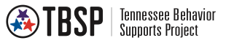
- Aggression Replacement Training
(Adapted from Midwest PBIS Network)

